Restaurant Guide

Group/Project 50

Matthew Beyene

101322548

Description of the functionality of the app

This project is for users to keep track of the restaurants they visit, and upload information regarding the restaurant. The users can fill name of restaurant, address, phone number, description, tag, and latitude and longitude for map. Users can edit the information anytime and add rating or change rating. Users can open location into map on their device. Users can share via email. Every restaurant added will be on list of restaurants main page.

Link to my wireframe / navigation structure

<https://www.figma.com/file/rIuhO7SXMdJvwuhHppssGC/Untitled?node-id=0%3A1&t=ESvYRg7U12qrQ8NM-1>

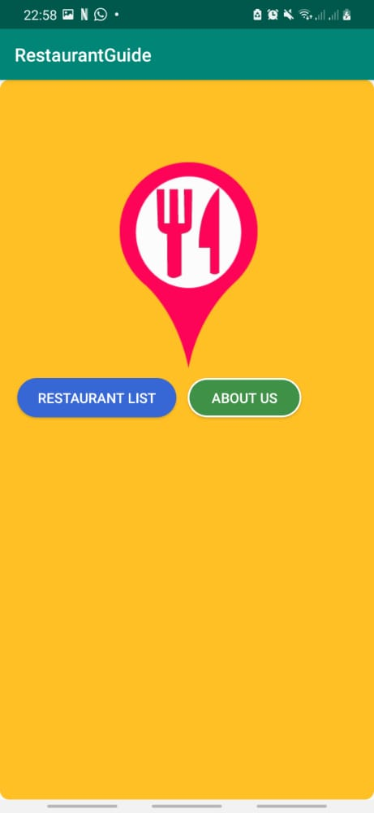

The starting page consists of these two options “Restaurant list” & “About Us’

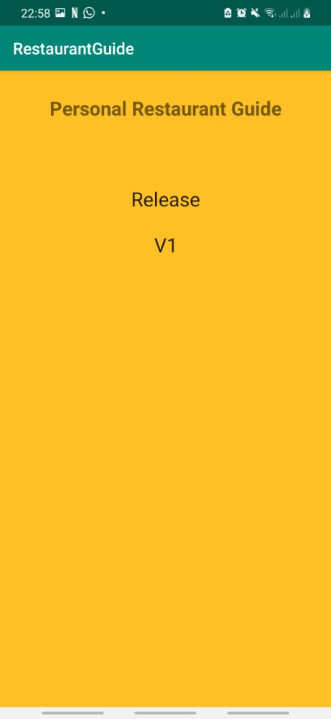

When selecting the “About Us’ option this is the page that comes up

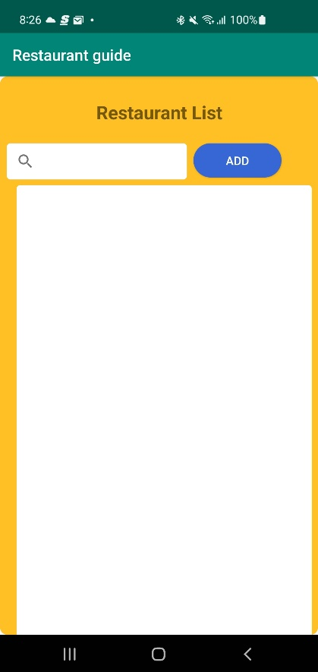

When “Restaurant list” is selected, it brings us to this page allowing us to add restaurants

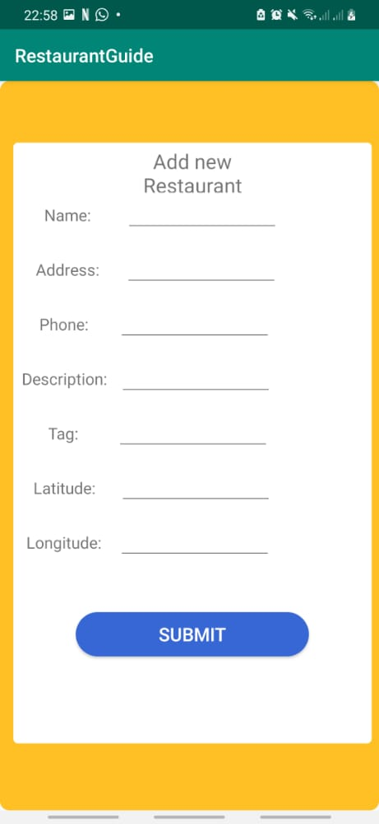

After selecting add, this page is for us to add our information regarding the restaurant we want to add on list

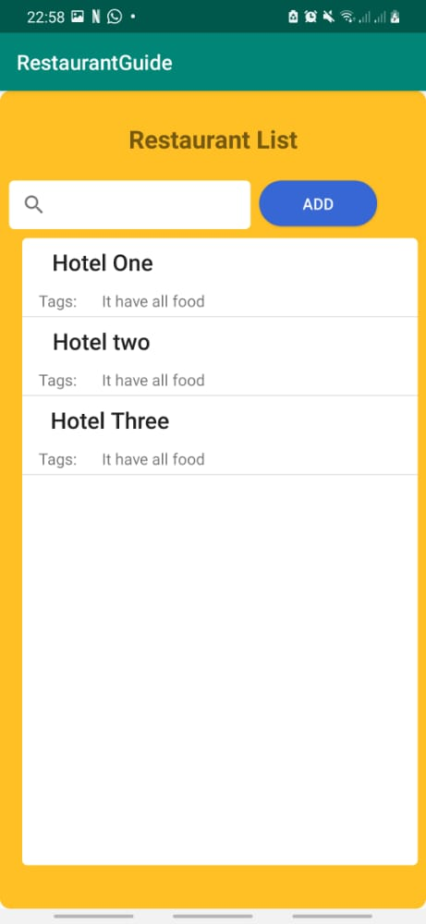

this is how it looks when adding a few restaurants.

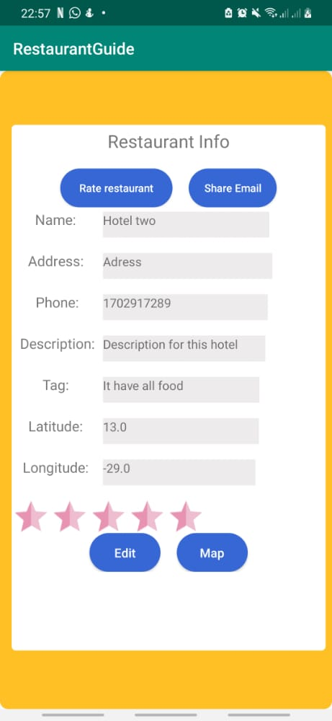

Selecting one of our restaurant listings added, it takes us to a page where we can edit it, check location on map, rate restaurant, and share via email.

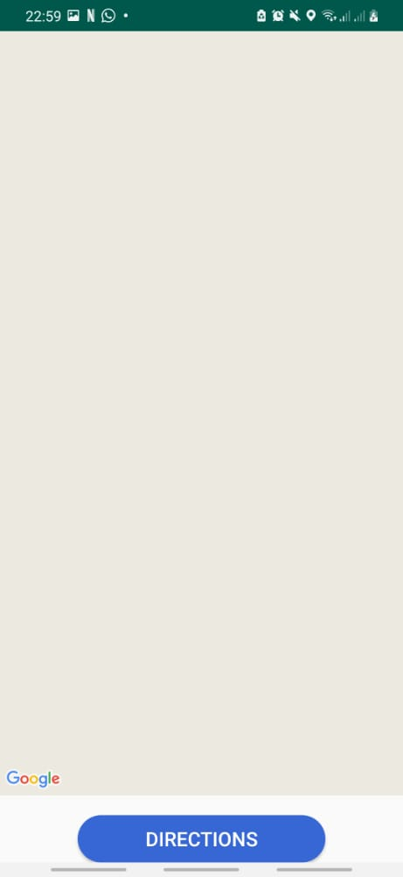

After selecting map it takes us to our maps

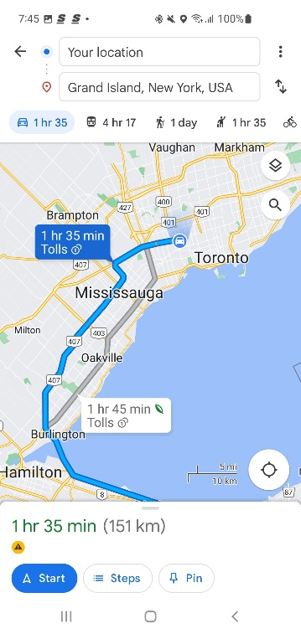

Here is a location that was randomly set with the latitude and longitude values.

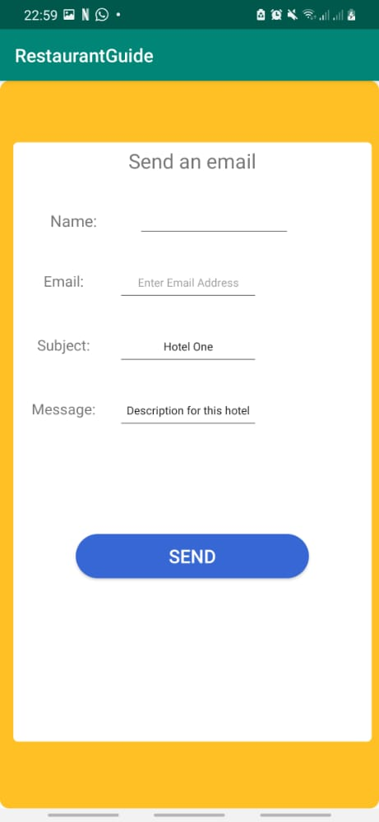

Going back to our restaurant info page (4th pic) we have the option to share via email, this is the page.